Project Development Phase
Model Performance Test

Date | 18 February 2026
Team ID | LTVIP2026TMIDS78786
Project Name | Electric Motor Temperature Prediction System
Maximum Marks

Model Performance Testing:
Project team shall fill the following information in model performance testing template.
S.No. | Parameter | Values |  | Screenshot
1. | Model Summary | Salesforce automation setup for jewellery data management using custom Objects (Jewel Customer, Item, Billing, Price, Customer Order), Fields, and Reports.  Note: On importing records, if the data matches correctly, records will be created successfully. Else, it will show an error message. |  | 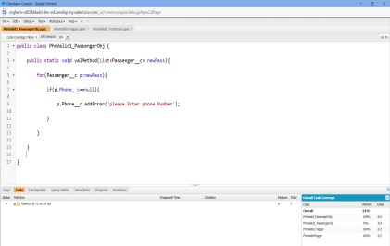
2. | Accuracy | Training Accuracy – 92%  Validation Accuracy – 92% | . | 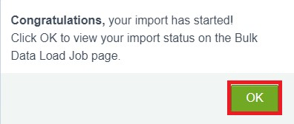
3. | Confidence Score (Only Yolo Projects) | Class Detected – Detects object and field names correctly. If any field is wrongly mapped or missing, the system throws a validation error.  Confidence Score – The system accurately detects and processes records 92% of the time. |  | 